hostinger.com

What Is CLI?
Domantas G.
10-12 minutes

Mar 17, 2022
Domantas G.
6min Read
CLI is a powerful program, but its use CLI hasn’t always been well-received. Beginners are reluctant to use it, thinking that it is only for advanced users. But, that is not true.
Download Glossary For Web Beginners
In this article, you will learn everything you need to know about CLI.
- What Is CLI?
- The Roots of CLI
- Shell – The Foundation Behind CLI
  - Windows Shell
  - Bash
- Why Would You Use CLI over GUI?

What Is CLI?
CLI stands for command line interface. It is a program that allows users to type text commands instructing the computer to do specific tasks.

The Roots of CLI
In the 1960s, CLI was used intensively.
Back then, people had only a keyboard as an input device and the computer screen could only display text information. The operating systems like MS-DOS used the CLI as the standard user interface.
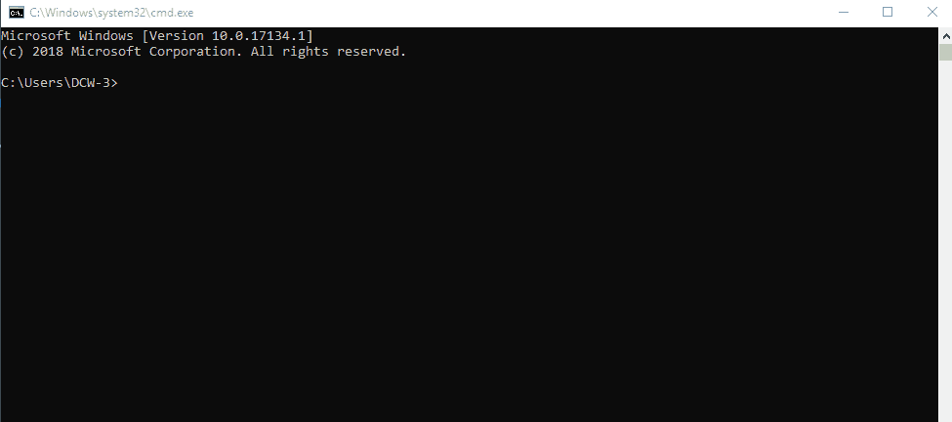
Basically, users had to type a command on the CLI to perform tasks, as this was the only way to communicate with the computer.
After typing a command, the result users got would be either text information or specific action performed by the computer. That being said, typing the right command is the key.
If users type the wrong command, chances are they’ll end up deleting the wrong files or accidentally closing the program before saving their work. This is what people consider as the main drawback of using CLI.
Then, after years of only using a keyboard and risking to misuse the command line, the mouse was invented.
The invention of a mouse marked beginning of the point-and-click method as a new way to interact with the computer.
This method is much safer for average users, thus drove them away from CLI. But, later on, we will discuss that using CLI is better. Stay with us.
Apart from that, operating systems started to develop an attractive way of computing, using GUI (Graphical User Interaction). GUI itself was phenomenal because of the use of buttons and menus to represent specific commands. This approach has been proven to be very intuitive.
Today, GUI has become a common way of computing. However, most operating systems still offer a combination of CLI and GUI. For example, Mac users can either type “cal” in Terminal or click on a Calendar application to get the same results.

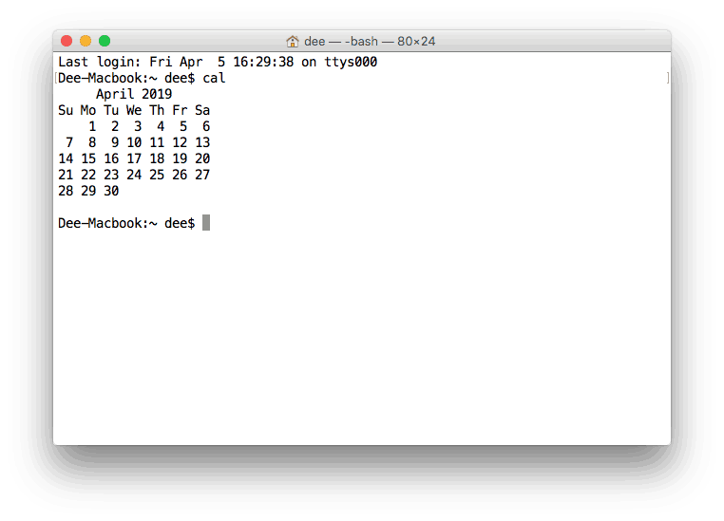Shell – The Foundation Behind CLI
If we dive from CLI into the deeper part of an operating system, we will find the shell.
Shell is a user interface responsible for processing all commands typed on CLI. It reads and interprets the commands and instructs the operating system to perform tasks as requested.
In other words, a shell is a user interface that manages CLI and acts as the man-in-the-middle, connecting users with the operating system.
In practice, there are many things that shell can process, such as:
- Working with files and directories
- Opening and closing a program
- Managing computer processes
- Performing repetitive tasks
Among many types of shell, the most popular ones are Windows shell (for Windows) and bash (for Linux and MacOS).

Windows Shell
The default shell in Windows is CMD.exe or the Command Prompt. In fact, Microsoft has used the Command Prompt since the old days, where MS-DOS was the main operating system.
To open the Command Prompt, you can click Start -> All Programs -> Accessories -> Command Prompt. Or, you can simply press Windows+R, then type CMD, and press enter.
Depending on what you need, type in either a single command or a combination. You can also type commands that run within a sequence (one command is executed after another).
The Command Prompt is so robust that it can manage many things within the Windows operating system:
- Changing directories, listing directories, content, etc
- Handling networking like displaying IP networks settings
- Managing files like renaming, moving, etc
- Managing media like formatting and renaming volumes
Now, let’s learn how to use some syntax in the command prompt:
- Changing directory
To navigate to a specific directory or folder in the command prompt, use CD [path]. Make sure you add space before the intended path. For example:
CD C:\Program Files
- Renaming a file
To rename a file within a specific folder, use REN [drive:][path] [source] [target].If you mention the location, that means the renamed file will be saved in the same folder. For example:
REN d:untitled.txt untitled1.txt
- Deleting a file
To delete a file in the command prompt use DEL [filename]. If you want to add the options like force deletion, you can add it before the file name. For example:
DEL /F untitled.txt
- Renaming a Volume Disk
To edit the name of a specific volume disk, use LABEL [drive:][new volume name]. Keep in mind that you can use up to 32 characters on NTFS volume and 11 on FAT volume. For example:
D:\ > LABEL d:MyData

Bash
Bash stands for Bourne Again SHell and was developed by the Free Software Foundation.
Bash is a type of shell used in MacOS and many Linux distributions. However, you can also install bash Linux on Windows 10.
In Linux, Bash shell is one of many shells the Linux users can use. The other types are Tchs shell, Ksh shell, and Zsh shell.
In most Linux distributions, the shell is located under the Utilities menu. If you use Gnome desktop, the name is Terminal, but if you use KDE, the name is Konsole.
Meanwhile, in MacOS, the program is Terminal.app. To run this program, go to Application -> Utilities -> Terminal. Or, you can simply type terminal using Spotlight search.
Once the terminal’s opened, you can start typing a command. Basically, most commands consist of: the command itself, the argument, and the option.
While the command contains the instruction we want to perform, the argument tells where the command should operate and the option requests the modification of the output.
Now it’s time to learn how to use the shell.
To begin with, you need to know the syntax to deal with the shell. This is also known as shell scripting – ways of using the script in CLI to run certain tasks.
While there are many commands you can use with CLI, they all fall into two categories:
- The commands that handle the processes
- The commands that handle the files
To understand the command syntax in MacOS, let’s learn from these examples:
- List all files in a folder
To know what files under a specific folder, use ls.
The default command will exclude the hidden files. To show all files, you can add -a. For example:
ls -a
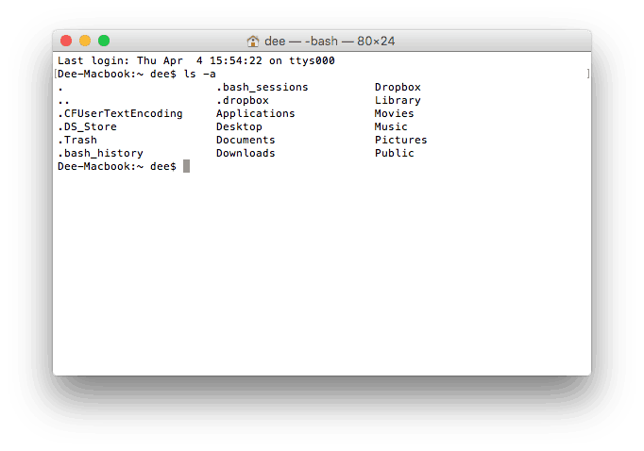
- Change directory
To move to a specific directory, use cd destination. For example:
cd ~/Desktop
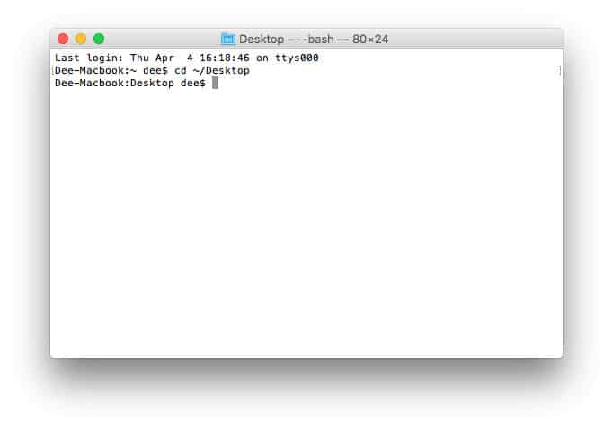
- Rename file
To rename a file within a specific folder, use mv source destination. Keep in mind, that you need to make sure the name of the file and the extension. For example:
mv ~/Desktop/untitled.rtf ~/Desktop/untitled1.rtf
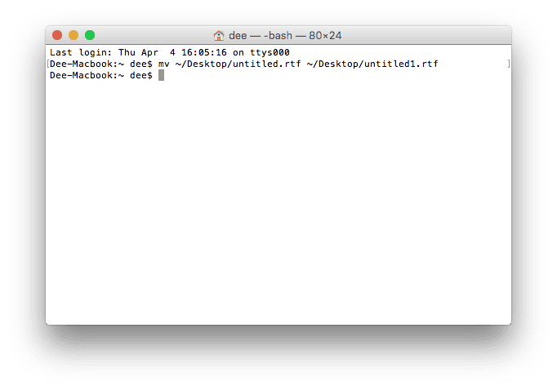
- Delete a file
To delete a file in the specific folder use rm filename. To avoid deleting the wrong file, make sure you move to the right folder destination first. For example:
rm untitled.rtf
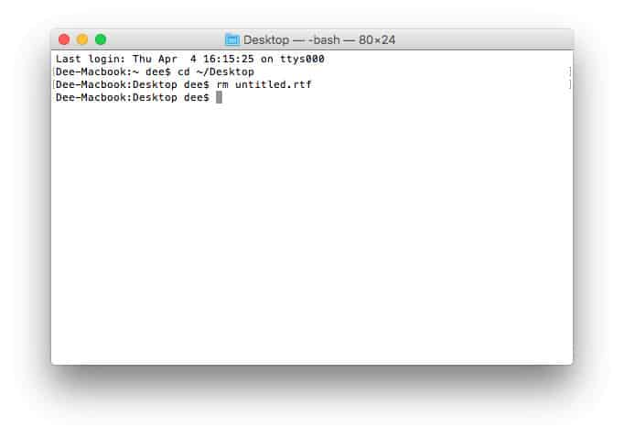
Again, typing the right command is important. That means you should pay attention to each character you use, including space. Not only that, make sure you type the correct case.
If for certain reasons you want to stop the ongoing process on the Command Prompt or Bash, simply hit Control+C.

Why Would You Use CLI over GUI?
As previously mentioned, the GUI was developed within the operating system as soon as the mouse became a new input device to operate the computer.
We should admit that GUI is visually attractive and easily understood. But, for some tasks which are vital, CLI is way more powerful.
Here, we would like to pick some points why you would use CLI over GUI. However, we leave it to you to choose depending on your type of work.
- Less Resource
It is not a secret that the text-based program needs very little resources of your computer. This means that with CLI you can do similar tasks with minimum resources.
- High Precision
You can use a specific command to target specific destinations with ease. As long as you don’t type the wrong command, it will work like a charm. Once you learn the basics, writing syntax is not as hard as you might think.
- Repetitive Tasks Friendly
GUI has developed well over the years. But, the operating system may not give you all the menus and buttons to perform all tasks. One of the reasons is safety. This leaves you overwhelmed if you have to do repetitive tasks. For example, when you have to handle hundreds of files within a folder, CLI enables you to use a single command to do automate the repetition easily.
- Powerful
Most operating systems today prevent you from messing up the system’s core process. Windows has system protection and MacOS has SIP (System Integrity Protection). You won’t be able to perform certain tasks which are system protected. However, with CLI, you will have full control over your system.
To give you an illustration, there is a method called PSD to HTML in website development.
In PSD to HTML, the process starts with making a mockup in Photoshop. The Photoshop Document (PSD) is then converted to HTML.
Converting PSD to HTML involves hand-coded work. The developer will make sure that the code used in the conversion is clean. This is important to pass W3C compliance.
W3C compliance will ensure that the website has good code to make it compatible with all browsers.
So, understanding the code is vital to understand the core process.
The same thing goes for CLI in the operating system. While the GUI may seem appealing, CLI is light, powerful and straightforward.

Conclusion
Despite a long debate that CLI is only for the experts, you have now learned it is for average users as well.
The fact that most operating system still provides CLI along with GUI proves that CLI is crucial. Also, using CLI gives more positive points than GUI because:
- It needs fewer resources
- It ensures high precision
- It handles repetitive task easily
- It is powerful
Now, let’s get the job done using CLI!

Domantas leads the content and SEO teams forward with fresh ideas and out of the box approaches. Armed with extensive SEO and marketing knowledge, he aims to spread the word of Hostinger to every corner of the world. During his free time, Domantas likes to hone his web development skills and travel to exotic places.

What Is the Difference Between Buffering & Streaming?
Buffering is actually an action taken to improve the streaming experience; streaming is commonly used on the Internet for media consumption because the viewer only needs the segment of the media they are currently viewing to enjoy the content as opposed to the entire thing with downloading. Buffering a stream helps work around any inconsistencies in the data flow while streaming content.

Streaming
Streaming minimizes the amount of time it takes for a viewer to start viewing media over the Internet after starting a data transfer; whatever media you're watching is downloading while you watch. According to the BBC, "Streaming means listening to music or watching video in ‘real time’, instead of downloading a file to your computer and watching it later." Streaming is particularly useful when a media consumer's Internet connection speed would allow them to download media completely in less time than it would take to view. Websites and services often use streaming to distribute audio and video content; computer programs like Microsoft Office On Demand and various video games can also be streamed.

Buffer
The buffer is an allocated data storage space that contains information from the stream that the viewer or user is likely to use. In the case of a media stream like music or a movie, the buffer contains upcoming content the viewer hasn't seen or heard yet. The buffer may also contain recently viewed content for fast rewinding. When streaming programs, the buffer contains parts of the program the user has called and will likely call.

Buffering Improves Streaming
The buffer is designed to hold upcoming information to provide the smoothest possible consumption experience. The buffer is designed to account for inconsistent data provision speed changes and temporary service loss. Additionally, buffering before starting a stream can provide the stream at a higher-quality than in real-time. For example, if an audio stream runs at 256kbps but a listener's Internet connection only runs at 200kbps, the stream could spend 30 seconds preloading the song before starting playback so the download completes at the same time the song playback ends. The same pre-loading concept works for a movie that can play back in 12mbps but the viewer only has an 11mbps download speed.

Streaming without Buffering
Streaming content without a buffer leaves the viewer at the mercy of a constant data stream speed. If a video stream has no buffer or too little buffer, it will start to get choppy, drop in quality or temporarily pause if anything happens to disrupt the connection as it goes from the server to the viewer's device. Things like the source server getting a temporary load increase, the Internet connection fizzling out, a small number of data packets getting lost in the transfer or even someone else on the same network browsing a website can all interrupt the feed.

- Binary file, composed of something other than human-readable text
- Executable, a type of binary file that contains machine code for the computer to execute

Source code and Object code
Source code is the fundamental component of a computer program that is created by a programmer. It can be read and easily understood by a human being. When a programmer types a sequence of C programming language statements into Windows Notepad, for example, and saves the sequence as a text file, the text file is said to contain the source code.
Source code and object code are sometimes referred to as the "before" and "after" versions of a compiled computer program. For script (noncompiled or interpreted) program languages, such as JavaScript, the terms source code and object code do not apply, since there is only one form of the code.
Programmers can use a text editor, a visual programming tool or an integrated development environment (IDE) such as software development kit (SDK) to create source code. In large program development environments, there are often management systems that help programmers separate and keep track of different states and levels of source code files.

Object code consists mainly of the numbers one and zero and cannot be easily read or understood by humans. Object code can then be "linked" to create an executable file that runs to perform the specific program functions.
In the 1950s and '60s, source code was often provided for free with software by the companies that created the programs. As growing computer companies expanded software's use, source code became more prolific and sought after. Computing magazines prior to the internet age would often print source code in their pages, with readers needing to retype the code character for character for their own use. Later, floppy disks decreased the price for electronically sharing source code, and then the internet further deleted these obstacles.

What are rich text features?

Rich text is more exciting than plain text. It supports text formatting, such as bold, italics, and underlining, as well as different fonts, font sizes, and colored text. Rich text documents can also include page formatting options, such as custom page margins, line spacing, and tab widths.

pugixml supports various architectures, such as x86/x86-64, PowerPC, ARM, MIPS and SPARC. In general it should run on any architecture since it does not use architecture-specific code and does not rely on features such as unaligned memory access.
pugixml can be compiled using any C++ compiler; it was tested with all versions of Microsoft Visual C++ from 6.0 up to 2015, GCC from 3.4 up to 5.2, Clang from 3.2 up to 3.7, as well as a variety of other compilers (e.g. Borland C++, Digital Mars C++, Intel C++, Metrowerks CodeWarrior and PathScale)

Git is like cloud. Git is the environment/framework/concept.
It has three stages:
1. add – stage
2. commit – local repo
3. push – to the remote repo – like cloud storage(onedrive, gdrive, etc.,) so that it is accessible everywhere. - internet

you can contribute from the outside wihtout permission from the owner by forking.

To get the code you submitted reviewed by the owner for getting it published – you have to do a PR – pull request – requesting the owner to pull what you’ve pushed.

Branching is done to add additional linces of code while not affecting what has been accomplished so far. It can be merged into the main branch later.

Trees belong to the class of non-linear data structures. Unlike linear data structures, such as stacks or lists, where elements are stored in linear order, non-linear data structures store elements hierarchically. Thus the traversal of a tree or graph cannot be completed in a single run
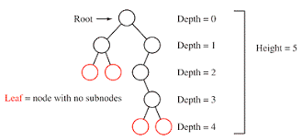
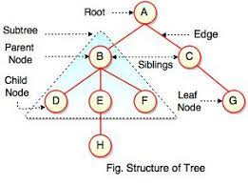

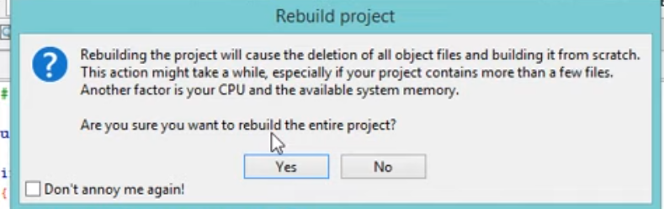

RUNTIME ENVIRONMENT
In computer programming, a runtime system or runtime environment is a sub-system that exists both in the computer where a program is created, as well as in the computers where the program is intended to be run. The name comes from the compile time and runtime division from compiled languages, which similarly distinguishes the computer processes involved in the creation of a program (compilation) and its execution in the target machine (the run time).[1]
Most programming languages have some form of runtime system that provides an environment in which programs run. This environment may address a number of issues including the management of application memory, how the program accesses variables, mechanisms for passing parameters between procedures, interfacing with the operating system, and otherwise. The compiler makes assumptions depending on the specific runtime system to generate correct code. Typically the runtime system will have some responsibility for setting up and managing the stack and heap, and may include features such as garbage collection, threads or other dynamic features built into the language.[1]

Difference between compilers and interpretors
A compiled language is a programming language whose implementations are typically
compilers (translators that generate machine code from source code), and not
interpreters (step-by-step executors of source code, where no pre-runtime translation takes place).

Advantages and disadvantages
Programs compiled into native code at compile time tend to be faster than those translated at runtime due to the translation process's overhead. Newer technologies such as just-in-time compilation, and general improvements in the translation process are starting to narrow this gap, though. Mixed solutions using bytecode tend toward intermediate efficiency.
Low-level programming languages are typically compiled, especially when efficiency is the main concern, rather than cross-platform support. For such languages, there are more one-to-one correspondences between the programmed code and the hardware operations performed by machine code, making it easier for programmers to control the use of central processing unit (CPU) and memory in fine detail.
With some effort, it is always possible to write compilers even for traditionally interpreted languages. For example, Common Lisp can be compiled to Java bytecode (then interpreted by the Java virtual machine), C code (then compiled to native machine code), or directly to native code. Programming languages that support multiple compiling targets give developers more control to choose either execution speed or cross-platform compatibility.

Time and space constraints
he ontology for time and space draws its inspiration from the decomposition of a conceptual
graph into its (mostly) binary relations. Each relation is of one of four kinds: temporal, which
links two acts; spatial, which links two objects; property, which links an object or an act to
one of its properties; and case, which links acts to objects. Each of the first three kinds of
relation can serve as input to or output from an actor.
In the temporal domain, inputs are partial states and schematics, since these are exactly
what is expected to change in time. A state is an object and its properties; a schematic is a
set of objects and their spatial relationships. ‘Partial’ indicates one binary relationship taken
from a number of them. Each temporal actor has an act as input, at least one partial state
or schematic as input and one as output. The crucial part of the whole idea of the overlay
comes, however, with the temporal relationships that the act bears to the inputs and outputs.
We have appealed to simple ideas of causality to analyze the possible relationships.

In the temporal domain, inputs are partial states and schematics, since these are exactly
what is expected to change in time. A state is an object and its properties; a schematic is a
set of objects and their spatial relationships. ‘Partial’ indicates one binary relationship taken
from a number of them. Each temporal actor has an act as input, at least one partial state
or schematic as input and one as output

Java is platform-independent.
Once compiled into byte code, it can be executed on any platform.

Java is a compiled as well as an interpreted language.

Factoring
Decomposition in computer science, also known as factoring, is breaking a complex problem or system into parts that are easier to conceive, understand, program, and maintain.

Code refactoring
The process of restructuring existing computer code—changing the factoring—without changing its external behavior. Refactoring is intended to improve the design, structure, and/or implementation of the software (its non-functional attributes), while preserving its functionality. Potential advantages of refactoring may include improved code readability and reduced complexity; these can improve the source code's maintainability and create a simpler, cleaner, or more expressive internal architecture or object model to improve extensibility. Another potential goal for refactoring is improved performance; software engineers face an ongoing challenge to write programs that perform faster or use less memory.

Typically, refactoring applies a series of standardised basic micro-refactorings, each of which is (usually) a tiny change in a computer program's source code that either preserves the behaviour of the software, or at least does not modify its conformance to functional requirements.

BUG
A software bug is an error, flaw or fault in the design, development, or operation of computer software that causes it to produce an incorrect or unexpected result, or to behave in unintended ways.
The process of finding and correcting bugs is termed "debugging" and often uses formal techniques or tools to pinpoint bugs. Since the 1950s some computer systems have been designed to deter, detect or auto-correct various computer bugs during operations.

Vulnerabilities
Vulnerabilities are flaws in a computer system that weaken the overall security of the device/system. Vulnerabilities can be weaknesses in either the hardware itself, or the software that runs on the hardware. Vulnerabilities can be exploited by a threat actor, such as an attacker, to cross privilege boundaries (i.e. perform unauthorized actions) within a computer system. To exploit a vulnerability, an attacker must have at least one applicable tool or technique that can connect to a system weakness. In this frame, vulnerabilities are also known as the attack surface.

Why is it called a kernel?

It is the primary interface between the hardware and the processes of a computer. The kernel connects these two in order to adjust resources as effectively as possible. It is named a kernel because it operates inside the OS, just like a seed inside a hard shell.

Kernel - The essential part of the seed. Everything inside the seed wall. Bean - The name given to some leguminous seeds

The kernel is the essential center of a computer operating system (OS). It is the core that provides basic services for all other parts of the OS. It is the main layer between the OS and hardware, and it helps with process and memory management, file systems, device control and networking.

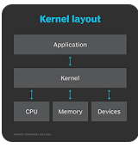

Knowing the Variable type
I'm not sure if my answer would help.
The short answer is, you don't really need/want to know the type of a variable to use it.
If you need to give a type to a static variable, then you may simply use auto.
In more sophisticated case where you want to use "auto" in a class or struct, I would suggest use template with decltype.

GIT
Git is a DevOps tool used for source code management.
GIT full form is “Global information Tracker” git is a free service to store your programme online anyone can edit on that programme.

It is a free and open-source version control system used to handle small to very large projects efficiently.
Git is used to tracking changes in the source code, enabling multiple developers to work together on non-linear development

Git is a free and open source distributed code management and Version control system that is distributed under the GNU General Public License version 2. In addition to software version control, Git is used for other applications including configuration management and content management.

FOSS-Free and open-source software

Open source - denoting software for which the original source code is made freely available and may be redistributed and modified. Anyone can contribute.
Open source software is code that is designed to be publicly accessible—anyone can see, modify, and distribute the code as they see fit.

GNU Project
The GNU Project is a free software, mass collaboration project that Richard Stallman announced on September 27, 1983. Its goal is to give computer users freedom and control in their use of their computers and computing devices by collaboratively developing and publishing software that gives everyone the rights to freely run the software, copy and distribute it, study it, and modify it. GNU software grants these rights in its license.
In order to ensure that the entire software of a computer grants its users all freedom rights (use, share, study, modify), even the most fundamental and important part, the operating system (including all its numerous utility programs) needed to be free software. According to its manifesto, the founding goal of the project was to build a free operating system, and if possible, "everything useful that normally comes with a Unix system so that one could get along without any software that is not free." Stallman decided to call this operating system GNU (a recursive acronym meaning "GNU's not Unix!"), basing its design on that of Unix, a proprietary operating system.[4] Development was initiated in January 1984. In 1991, the Linux kernel appeared, developed outside the GNU project by Linus Torvalds,[5] and in December 1992 it was made available under version 2 of the GNU General Public License.[6] Combined with the operating system utilities already developed by the GNU project, it allowed for the first operating system that was free software, commonly known as Linux.
The project's current work includes software development, awareness building, political campaigning and sharing of the new material.
Although Torvalds believes "open source is the only right way to do software", he also has said that he uses the "best tool for the job", even if that includes proprietary software.[31] He was criticized for his use and alleged advocacy of the proprietary BitKeeper software for version control in the Linux kernel. He subsequently wrote a free-software replacement for it called Git.

Towards data science.com

After some time, it became really hard to manage and maintain all the changes and updates. That is the reason why Git was created.
Git is a version control system. It maintains a history of all changes made to the code. The changes are stored in a special database called “repository”, also known as “repo”.
Two main advantages of using Git at software development:
- Tracking the changes and updates. We are able to see who made which changes. Git also provides when and why a change was made.
- Allowing to work collaboratively. Software development projects usually require many people to work together. Git provides the developers with a systematic way of doing that. Thus, the developers focus on the project instead of extensive communication sessions between the other developers.
There are other version control systems such as Subversion, Mercurial and so on. However, Git is the most popular one. Some of the reasons that make Git the preferred one are:
- Speed
- Scalability
- Being free and open source

Basic workflow
Assume I have project files in my project directory. I make some changes on a file and want to add the updated file in the git repository.
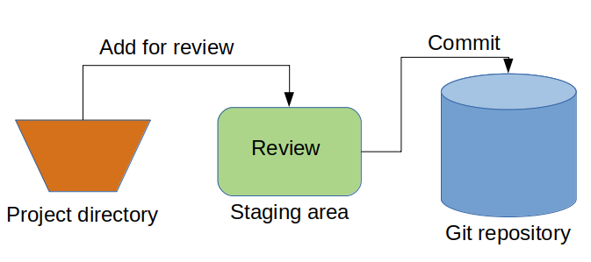
The first step is to add the updated file to the staging area. After review, it is committed to the git repository.
The word “commit” means a lot and it is a fundamental operation in Git. Let’s delve into what happens when we commit a file to the repository.
Git takes a snapshot of the project and stores it in the repository along with some other identifying information.
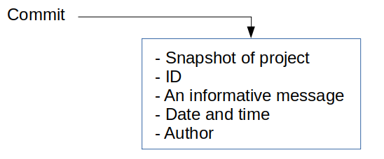
Each time we commit, Git records the information above. Thus, we have a highly useful history of the project.
When we commit a file, we provide a message that describes the change. This message should be as informative as possible in order to build a decent history.
Note: The advantage of saving all these information for every change is that we can easily revert back to an earlier version in case of a mistake.
You may be wondering why Git is taking a snapshot of the entire projects instead of just recording the changes. When there are lots of changes, it is easier to record a snapshot instead of the changes. Besides, when going back to a previous version, it becomes very complicated to track down all the modifications.
One issue with recording the snapshot of entire project might be the space. We don’t have to worry about it because Git is quite efficient in storing the snapshots. Git does not store the duplicate content and also compresses the content.

https://www.freecodecamp.org/news/learn-the-basics-of-git-in-under-10-minutes-da548267cc91/

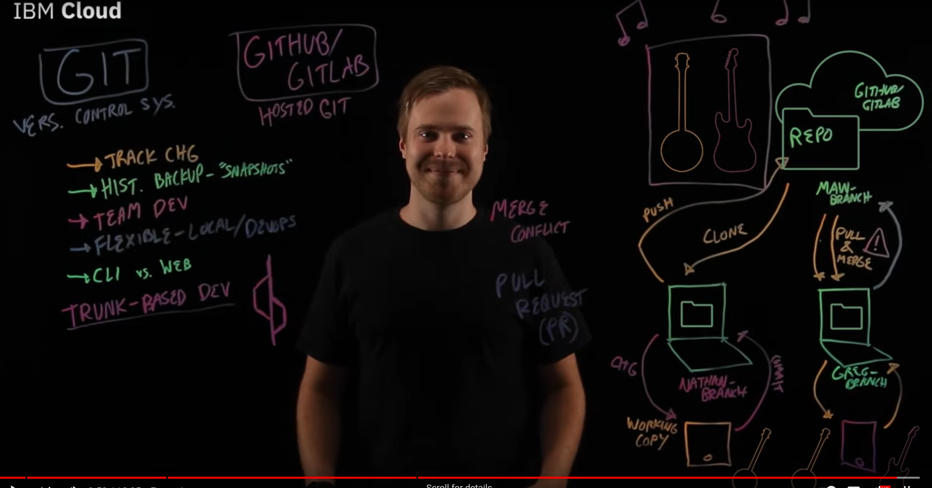

Setup a Project for Version Control with Git
- Create a new directory for this project. Name it anything you like, we'll refer to it as ProjDir here.
- In the ProjDir create a file called sample.txt. Add some text to the file. I added "My first edit of this file." to the file.
- Version control this project. From within the project directory run the command git init. This will create a .git directory and set you up to start version control.

Branching
Suppose we wanted to go back to a particular previous point in time ("snapshot") of our project and start working from that point from now on. Or suppose our project was in good shape but we were about to try some major changes and wanted to make sure we could easily go back to where we were before the major changes. Both cases call for creating a new branch. We'll look at both

What are Git tags?

Tags are ref's that point to specific points in Git history. Tagging is generally used to capture a point in history that is used for a marked version release (i.e. v1. 0.1). A tag is like a branch that doesn't change. Unlike branches, tags, after being created, have no further history of commits.

The difference between tags and branches are that a branch always points to the top of a development line and will change when a new commit is pushed whereas a tag will not change. Thus tags are more useful to "tag" a specific version and the tag will then always stay on that version and usually not be changed.

What is a pull request in Git? A pull request is an event in Git where a contributor asks a maintainer of a Git repository to review code they want to merge into a project.

Creating a pull request
Create a pull request to propose and collaborate on changes to a repository. These changes are proposed in a branch, which ensures that the default branch only contains finished and approved work
If you want to create a new branch for your pull request and do not have write permissions to the repository, you can fork the repository first. For more information, see "Creating a pull request from a fork" and "About forks."
You can specify which branch you'd like to merge your changes into when you create your pull request. Pull requests can only be opened between two branches that are different.

temporary value
C++ doesn't have anything called Temp. It is likely a variable that the person who wrote the code picked for some reason. Usually, it means the value isn't needed for more than a moment (i.e. it is a temporary value to be calculated, used, and forgotten.)Why do we use temp in program?

Temp is normally just a variable name used for something that will be deleted soon or will soon become out of scope. In this code, it is just used to check if sqrt had changed, if sqrt had not changed it can return 0

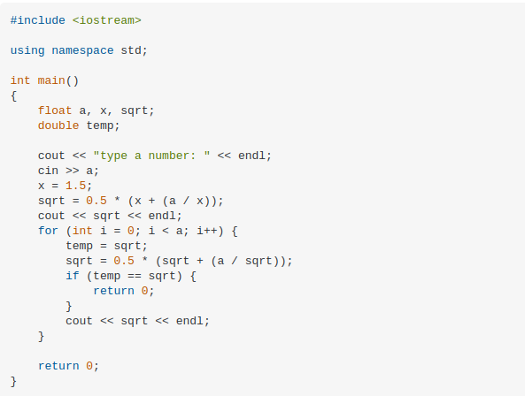

Text files vs binary file
Text files are organized around lines, each of which ends with a newline character ('\n'). The source code files are themselves text files. A binary file is the one in which data is stored in the file in the same way as it is stored in the main memory for processing.

Binary file contains the data in the form of 0 and 1(series of binary values) and text files contains the data in the form of stream of characters. In general binary files are identified as executable files. But binary files are not in readable form as like text file.

Files is collection of records (or) it is a place on hard disk, where data is stored permanently.

Types of Files
There are two types of files in C language which are as follows −
- Text file
- Binary File

Text File
- It contains alphabets and numbers which are easily understood by human beings.
- An error in a text file can be eliminated when seen.
- In text file, the text and characters will store one char per byte.
- For example, the integer value 4567 will occupy 2 bytes in memory, but, it will occupy 5 bytes in text file.
- The data format is usually line-oriented. Here, each line is a separate command.

Binary file
- It contains 1’s and 0’s, which are easily understood by computers.
- The error in a binary file corrupts the file and is not easy to detect.
- In binary file, the integer value 1245 will occupy 2 bytes in memory and in file.
- A binary file always needs a matching software to read or write it.
- For example, an MP3 file can be produced by a sound recorder or audio editor, and it can be played in a music player.
- MP3 file will not play in an image viewer or a database software.

Files are classified into following
- Sequential files − Here, data is stored and retained in a sequential manner.
- Random access Files − Here, data is stored and retrieved in a random way.

What is a binary file?
A binary file is a file whose content is in a binary format consisting of a series of sequential bytes, each of which is eight bits in length. The content must be interpreted by a program or a hardware processor that understands in advance exactly how that content is formatted and how to read the data. Binary files include a wide range of file types, including executables, libraries, graphics, databases, archives and many others.
Electronic files are typically categorized as either binary files or text files. It could be argued that text files are also a type of binary file because, like any electronic file, they're made up of sequences of bytes. However, the two are generally considered to be different types. Text files are in a human-readable format and typically adhere to specific character sets, such as Unicode.

How is a binary file used?
Binary files are not human readable and require a special program or hardware processor that knows how to read the data inside the file. Only then can the instructions encoded in the binary content be understood and properly processed.
The following screenshot shows part of the content from a file on a Mac computer. The content can be understood only by specific system architectures such as Mac. The file in this figure is a Unix executable binary file. As is typical with binary files, the file's content is a series of sequential bytes, lined up one after the other. Although we can view the bytes that make up the binary data, the file can be properly interpreted only by the target platform.

A binary file often includes some type of header that indicates the type of file. The header might include a few human-readable characters, but a binary file as a whole requires specific software or hardware to read the file and take action. On the other hand, a user can open a text file in a wide range of editors and make sense of the content without needing any special type of interpreter.
Binary files are commonly used when building applications and other types of software. However, developers do not work directly with the binary files. Instead, they build their applications in a high-level programming language such as C++ or Java. The languages use human-readable text files to define the application logic.
At certain intervals in the development process, the text files are submitted to a compiler that translates the source code into machine code, bytecode or another programming language. If the compiler generates bytecode, the bytecode will eventually be converted to machine code.
Machine code is submitted to a computer's processor in the form of binary files. The machine code files must target a specific computer platform, which refers to the combination of operating system and hardware architecture. For example, the binary machine code might target Windows and the Intel line of microprocessors, or it might target macOS and the Apple M-series chips. A different compiler is usually required for each computer platform.
In general, executable -- or ready-to-run -- programs are identified as binary files and given a filename extension such as .bin or .exe. Programmers often talk about an executable program as a binary or will refer to their compiled application files as binaries. These types of files might also be referred to as object code.
In terms of transmitting files from one place to another, a file can be transmitted as a binary, meaning the programs handling it don't attempt to look within it or change it. Instead, they just pass it along as a chunk of ones and zeros, the meaning of which is unknown to any network device.
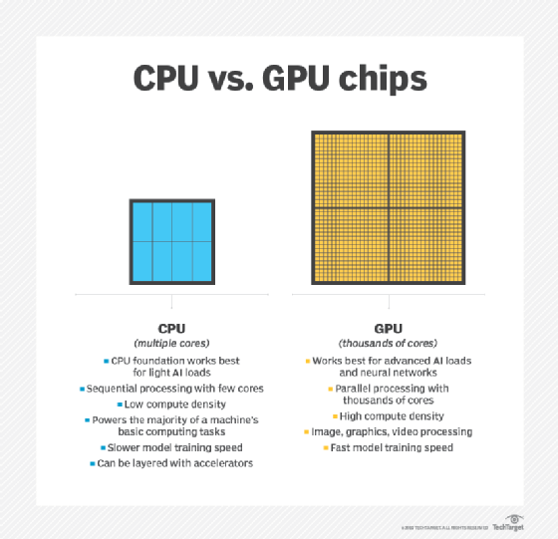

1920 x 1080
In the case of a monitor with an industry-standard Full HD 1080p resolution, this display has a resolution of 1920 x 1080. This means that the screen will have a width of 1,920 pixels while the height of the screen will be 1,080 pixels. This results in a grand total of 2,073,600 pixels on-screen.
How many pixels is 1080p resolution?

two million pixels
A High Definition TV with 1080p resolution is composed of two million pixels (1920 x 1080), while a 4K TV (aka Ultra High Definition) has over eight million pixels (3840 x 2160)

Is 1080p 1080 pixels per inch?

For instance, the standard 1920×1080 Full HD resolution will result in a different pixel density (or pixel-per-inch ratio) on a 24″ screen (92 PPI) and on a 27″ screen (82 PPI). More pixels per inch means more screen real estate, as well as sharper and clearer details.

Self-hosting is the practice of running and maintaining a website or service using a private web server, instead of using a service outside of someones own control. For example, someone wishing to write a blog could use hosted blog services. Alternatively, they could install content management system software on their own server to self-host their blog. [1]

On-premises software (abbreviated to on-prem, and incorrectly referred to as on-premise)[1] is installed and runs on computers on the premises of the person or organization using the software, rather than at a remote facility such as a server farm or cloud. On-premises software is sometimes referred to as "shrinkwrap" software, and off-premises software is commonly called "software as a service" ("SaaS") or "cloud computing".

Location
On-premises software is established within the organisation's internal system along with the hardware and other infrastructure necessary for the software to function.[3][4][5]
Cloud-based software is usually served via internet and it can be accessed by users online regardless of the time and their location.[3][4][5] Unlike on-premises software, cloud-based software users only need to install an application or a web browser in order to access its services.

Regular expression
regular expression (shortened as regex or regexp;[1] sometimes referred to as rational expression[2][3]) is a sequence of characters that specifies a search pattern in text. Usually such patterns are used by string-searching algorithms for "find" or "find and replace" operations on strings, or for input validation.

A Regular Expression (or Regex) is a pattern (or filter) that describes a set of strings that matches the pattern. In other words, a regex accepts a certain set of strings and rejects the rest.

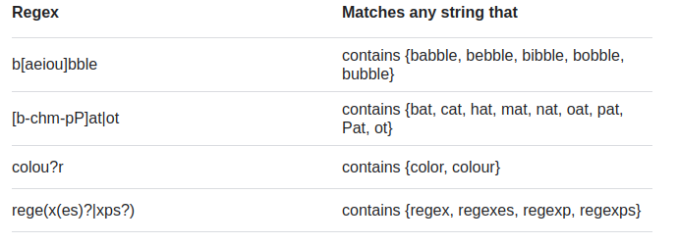

Regular expressions are particularly useful for defining filters. Regular expressions contain a series of characters that define a pattern of text to be matched—to make a filter more specialized, or general. For example, the regular expression ^AL[.]* searches for all items beginning with AL.

A fax (short for facsimile and sometimes called telecopying) is the telephonic transmission of scanned-in printed material (text or images), usually to a telephone number associated with a printer or other output device. The original document is scanned with a fax machine, which treats the contents (text or images) as a single fixed graphic image, converting it into a bitmap. In this digital form, the information is transmitted as electrical signals through the telephone system. The receiving fax machine reconverts the coded image and prints a paper copy of the document.

Almost all modems manufactured today are capable of sending and receiving fax data. Fax/modem software generates fax signals directly from disk files or the screen. Even if a document is text only, it is treated by the computer as a scanned image and is transmitted to the receiver as a bitmap. Faxing a message online works well if the recipient wants only to read the message.
However, if the document requires editing, it must be converted into ASCII text by an OCR (optical character recognition) program, or it must be retyped manually into the computer. A more efficient method of sending documents that require modification is through the e-mail system. E-mail files are already ASCII text so they can be edited immediately in any text editor or word processing program.

What does rendering actually do?

Video rendering refers to the process through which a computer system methodically processes information from a coded data source to transform that information to put together and display an image. In other words, rendering converts the source material into the final picture or footage

What is a rendering in design?

In 3-D graphic design, rendering is the process of add shading, color and lamination to a 2-D or 3-D wireframe in order to create life-like images on a screen. Rendering may be done ahead of time (pre-rendering) or it can be done in on-the-fly in real time.

Extended ASCII
To represent text in a computer system, we give each character its own special number. This number is called its code. We can then store this code in the computer using binary ones and zeros.
ASCII stands for American Standard Code for Information Interchange.
ASCII code allows computers to understand how to represent text. In ASCII, each character (letter, number, symbol or control character) is represented by a binary value. Extended ASCII is a version that supports representation of 256 different characters. This is because extended ASCII uses eight bits to represent a character as opposed to seven in standard ASCII (where the 8th bit is used for error checking).
The maximum number of characters that can be represented in extended ASCII is 256.
As an example, the ASCII code for uppercase A is 65.
Character | Code | Representation Binary
A | 65 | 01000001

Extended ASCII represents both control characters and printable characters.
Control characters are used to perform actions rather than to display a printable character on screen. Easily understood examples include 'Escape', 'Backspace' and 'Delete'.
Printable characters are used to show a character on screen. Letters, symbols, numbers and punctuation marks are all examples of printable characters.

The make Command and Makefiles:-
Although, as you will see, the make command has a lot of built-in knowledge, it can’t know how to build your application all by itself. You must provide a file that tells make how your application is constructed.This file is called the makefile.

The Syntax of Makefiles:-
A makefile consists of a set of dependencies and rules. A dependency has a target (a file to be created) and a set of source files upon which it is dependent. The rules describe how to create the target from the dependent files. Typically, the target is a single executable file.
The makefile is read by the make command, which determines the target file or files that are to be made and then compares the dates and times of the source files to decide which rules need to be invoked to construct the target. Often, other intermediate targets have to be created before the final target can be made. The make command uses the makefile to determine the order in which the targets have to be made and the correct sequence of rules to invoke.

A compiler generates object code files (machine language) from source code. A linker combines these object code files into an executable.
What is the difference between compiling and linking?

Compiling - The modified source code is compiled into binary object code. This code is not yet executable. Linking - The object code is combined with required supporting code to make an executable program. This step typically involves adding in any libraries that are required.

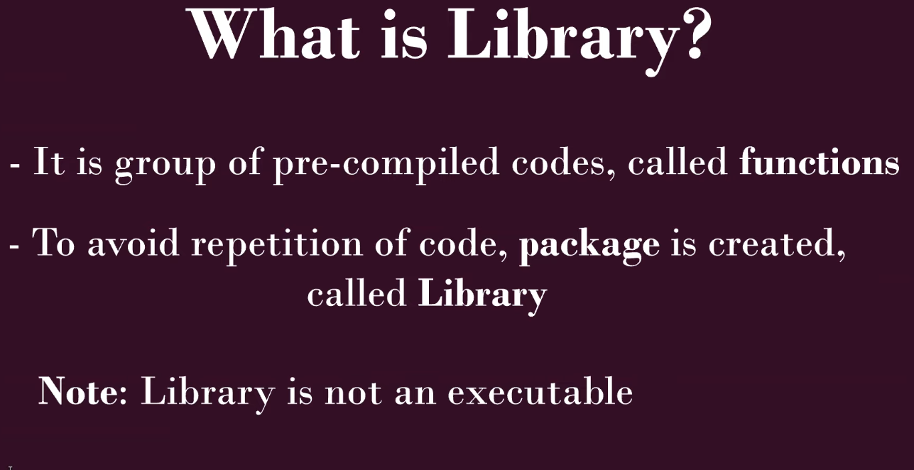
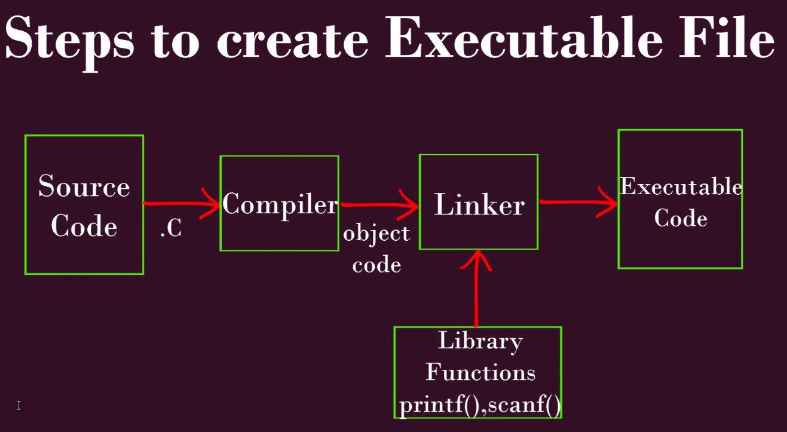

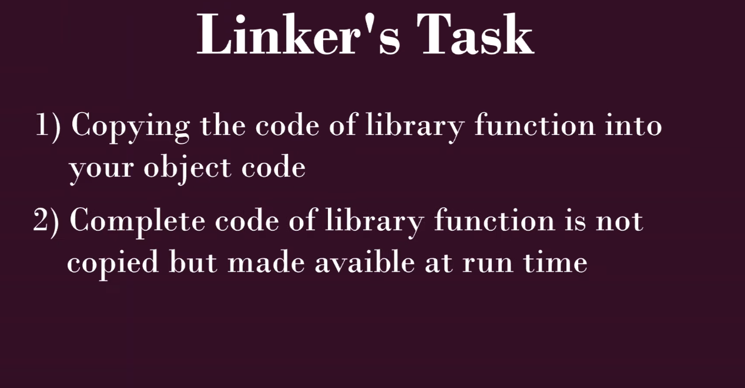

Long story short: CPU is not the only factor that can slow your program down. Memory can be important as well. Modern CPUs are fairly complex, so the following is very simplified: A reasonable example is image processing. One thread can pull a big part of an image row into cache. Afterwards it can process several pixels without the need to access global memory. If a second thread comes along and pulls a different image row into cache it will invalidate the first image row thats already in cache. Thread one will need to refetch the first row. Therefore you will process faster but at the cost of more memory access. If memory is already the limiting factor of your code, it will actually get slower. In reality most CPU can deal with those situations quite well, e.g. by choosing the appropriate core, using branch/cache-prediction or using smart hyperthreading. Also your compiler is helping a lot by adding prefetching, loop interchanging, loop fusion or even cache blocking.

